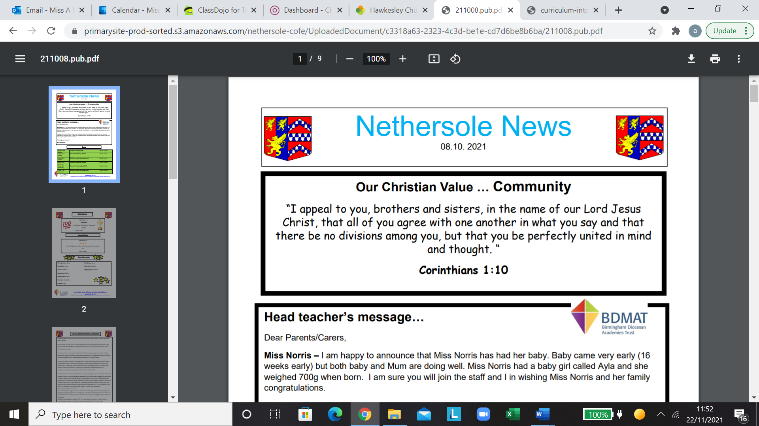
PSHE Knowledge Progression map
Linked with Jigsaw PSHE scheme of learning
Whole school Threads – PSHE Curriculum
Being me in my world | Celebrating Difference | Dreams and Goals | Healthy me | Relationships | Changing Me

Being me in my world
EYFS | Year One | Year Two | Year Three | Year Four | Year Five | Year Six
Help other to feel welcome. Making our school a safer place. Thinking about our right to learn. Caring for others.  Working well with others. | Explain why my class is a happy and safe place to learn.  Give different examples of where I or others make my class a safe and happy place. | Explain why my behaviour can impact others in my class.  Explain my own and  other’s choices and say why some choices are better than others. | Explain how my behaviour can affect how others feel and behave.  Say why it is important to have rules and how it helps me and others to learn. | Explain why being listened to and listening to others is important.  Explain why being democratic is important and helps others to feel valued. | Compare my life with other people around the UK and explain why we have rights, responsibilities and rules to make both school and the wider community a fair place.  Explain how actions of one person can affect another person. | Explain how my choices impact the local community and the wider world.  Empathise with other people in the local and wider community and think about how this changes my actions.

Celebrating difference
EYFS | Year One | Year Two | Year Three | Year Four | Year Five | Year Six
Accept that we are all different.  Include others when working and playing.  Know how to help other people. Try to solve problems.  Use kind words.  Give and receive compliments. | Tell you some ways that I am different and similar to other people in my class, and why this makes us all special.  Explain what bullying is and how being bullied might make somebody feel. | Explain that sometimes people get bullied because they are seen to be different; this might include people who do not conform to gender stereotypes.  Explain how it feels to have a friend and be a friend. I can also explain why it is OK to be different from my friends. | Describe different conflicts that might happen in family or friendship groups and how words can be used in hurtful or kind ways when conflicts happen.  Tell you how being involved with a conflict makes me feel and can offer strategies to help the situation. e.g. Solve It Together or asking for help | Tell you a time when my first impression of someone changed as I got to know them. I can also explain why bullying might be difficult to spot and what to do about it if I'm not sure.  Explain why it is good to accept myself and others for who we are. | Explain the differences between direct and indirect types of bullying and can offer a range of strategies to help myself and others if we become involved (directly or indirectly) in a bullying situation.  Explain why racism and other forms of discrimination are unkind. I can express how I feel about discriminatory behaviour. | Explain ways in which difference can be a source of conflict or a cause for celebration.  Show empathy with people in situations where their difference is a source of conflict or a cause for celebration.

Dreams and Goals
EYFS | Year One | Year Two | Year Three | Year Four | Year Five | Year Six
Stay motivated when doing something challenging.  Keep trying even when things are tricky. Work well with a partner or a group.  Have a positive attitude.  Help others to achieve their goals. | Explain how I feel when I am successful and how this can be celebrated positively.  Say why my internal treasure chest is an important place to store positive feelings. | Explain how I played my part in a group and the parts other people played to create an end product. I can explain how our skills complemented each other.  Explain how it felt to be part of a group and can identify a range of feelings about group work). | Explain the different ways that help me learn and what I need to do to improve.  Confident and positive when I share my success with others.  I can explain how these feelings can be stored in my internal treasure chest and why this is important. | Plan and set new goals even after a disappointment.  Explain what it means to be resilient and to have a positive attitude. | Compare my hopes and dreams with those of young people from different cultures. Reflect on the hopes and dreams of young people from another culture and explain how this makes me feel. | Explain different ways to work with others to help make the world a better place.  Explain what motivates me to make the world a better place.
Healthy Me
EYFS | Year One | Year Two | Year Three | Year Four | Year Five | Year Six
Make healthy choices. Eat a balance diet.  Be physically active.  Try to keep themselves and others safe.  Know how to be a good friend and have a healthy relationship.  Keep calm and deal with tricky situations. | Explain why I think my body is amazing and can identify a range of ways to keep it safe and healthy.  Give examples of when being healthy can help me feel happy. | Explain why foods and medicines can be good for my body comparing my ideas with less healthy/ unsafe choices.  Compare my own and my friends' choices and can express how it feels to make healthy and safe  choices. | Identify things, people and places that I need to keep safe from, and can tell you some strategies for keeping myself safe and healthy including who to go to for help.  Express how being anxious/ scared and unwell feels. | Recognise when people are putting me under pressure and can explain ways to resist this when I want to.  Identify feelings of anxiety and fear associated with peer pressure. | Explain different roles that food and substances can play in people's lives. I can also explain how people can develop eating problems (disorders) relating to body image pressures and how smoking and alcohol misuse is unhealthy. | Explain when substances including alcohol are being used anti-socially or being misused and the impact this can have on an individual and others.  Identify and apply skills to keep myself emotionally healthy and to

 |  |  |  |  | Summarise different ways that I respect and value my body. | manage stress and pressure.
Relationships
EYFS | Year One | Year Two | Year Three | Year Four | Year Five | Year Six
Know how to make friends.  Try to solve friendship problems when they occur.  Help others feel part of a group.  Show respect when dealing with other people.  Know how to help themselves and others when they feel upset.  Know and show what makes a good friendship. | Explain why I have special relationships with some people and how these relationships help me feel safe and good about myself.  I can also explain how my qualities help these relationships.  Give examples of behaviour in other people that I appreciate and behaviours that I don't like. | Explain why some things might make me feel uncomfortable in a relationship and compare this with relationships that make me feel safe and special.  Give examples of some different problem-solving techniques and explain how I might use them in certain situations in my relationships. | Explain how my life is influenced positively by people I know and also by people from other countries.  Explain why my choices might affect my family, friendships and people around the world who I don't know. | Recognise how people are feeling when they miss a special person or animal.  Give ways that might help me manage my feelings when missing a special person or animal. | Compare different types of friendships and the feelings associated with them. I can also explain how to stay safe when using technology to communicate with my friends, including how to stand up for myself, negotiate and to resist peer pressure.  Apply strategies to manage my feelings and the pressures I may face to use technology in ways that may be risky or cause harm to myself or others. | Identify when people may be experiencing feelings associated with loss and also recognise when people are trying to gain power or control.  Explain the feelings I might experience if I lose somebody special and when I need to stand up for myself and my friends in real or online situations. I can offer strategies to help me manage these feelings and situations.

Changing me
EYFS | Year One | Year Two | Year Three | Year Four | Year Five | Year Six
Understand that everyone is unique and special.  Can express how they feel when they are happy.  Understand and respect changes which happen in them.  Understand changes which happen in them.  Look forward to change. | Compare how I am now to when I was a baby and explain some of the changes that will happen to me as I get older. I can use the correct names for penis, testicles, anus, vagina, vulva, and give reasons why they are private.  Explain why some changes I might experience might feel better than others. | Use the correct terms to describe penis, testicles, anus, vagina, vulva and explain why they are private.  I can explain why some types of touches feel OK and others don't.  Tell you what I like and don't like about being a boy/ girl and getting older, and recognise that other people might feel differently to me. | Explain how boys' and girls' bodies change on the inside/outside during the growing up process and can tell you why these changes are necessary so that their bodies can make babies when they grow up.  Recognise how I feel about these changes happening to me and can suggest some ideas to cope with these feelings. | Summarise the changes that happen to boys' and girls' bodies that prepare them for making a  baby when they are older.  Explain some of the choices I might make in the future and some of the choices that I have no control over.  I can offer some suggestions about how I might manage my feelings when changes happen. | Explain how boys and girls change during puberty and why looking after myself physically and emotionally is important.  I can also summarise the process of conception.  Express how I feel about the changes that will happen to me during puberty, and that I accept these changes might happen at different times to  my friends. | Describe how a baby develops from conception through the nine months of pregnancy, and how it is born.  Recognise how I feel when I reflect on becoming a teenager and how I feel about the development and birth of a baby.

