
 The Nethersole CofE Academy Vision and Values

‘Let Your Light Shine’
Our Christian Vision for everyone to be unique shining lights in God’s world is illuminated by our biblically based Christian Values that we learn to radiate in our daily lives - in our attitudes, relationships, behaviour, choices and decisions.
Hope   |  | Community   | Dignity and Respect   | Forgiveness  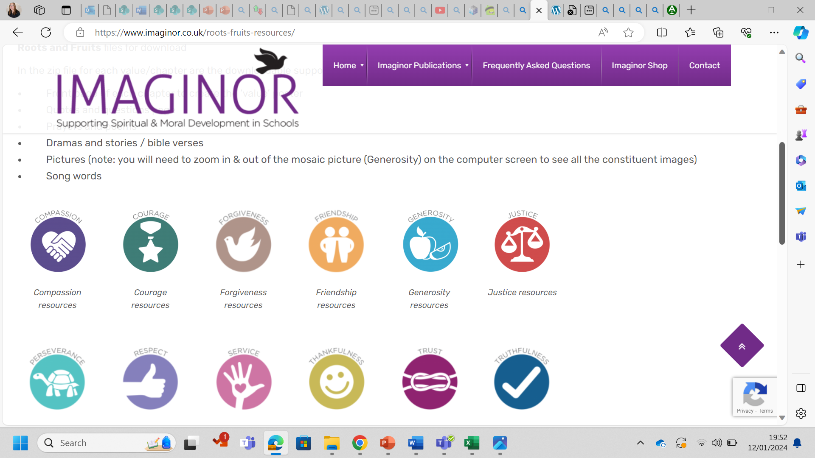 | Wisdom   | Thankfulness  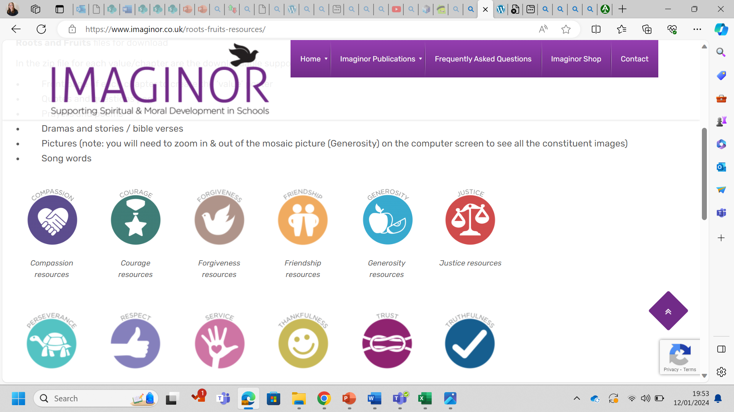
Intent
Our curriculum intent at The Nethersole CofE Academy is to provide a broad, exciting, and challenging curriculum of the highest quality for the children in our care; encouraging, motivating and ensuring all children develop a love of learning, in order to achieve their full potential.
Implementation
Our curriculum will be implemented through knowledge-led experiences, enabling the children to increase their knowledge, learn and master new skills and therefore, deepen their understanding in a wide range of subjects.
Impact
The impact of this broad, exciting, and challenging curriculum is to inspire and motivate the young people in our care to become lifelong learners. We also provide a Christian community to enable all to value faith. All pupils are encouraged to be proud of their own culture, religion and language and show respect to those of others.
Our Vision | To be light (living in our community and reaching out beyond it) bringing out the God-colours in the world.’  Jesus said, ‘You’re here to be light, bringing out the God-colours in the world.’ Matthew 5:16
The Nethersole Church of England Academy Primary School and Nursery has a Christian foundation that inspires its life and work. Following the teaching of Jesus, we accept the challenge - ‘to be light [living in our community and reaching out beyond it], bringing out the God-colours in the world.’ Matthew 5:16
At the heart of our school is the belief that everyone is a child of God, fearfully and wonderfully made in his image. Our work therefore is to nurture and love every individual, child and adult, to find and develop their gifts, overcoming barriers and growing in confidence to flourish - to let their light shine as the very best God version of themselves. Effective teaching and learning underpin this. We wish to inspire everyone to take responsibility for creation, civilisation, and the well-being of each of other, embracing and treasuring our differences.
Our Christ led vision is for a world of justice, respect, and love, and of people who are not afraid to love and sacrifice themselves for others. Our inspiration is Jesus, who loves us in sacrifice, forgives us and reminds us that we each have something special to do to bring out the God colours of the world. We believe that there is a space for everyone to shine brightly and differently and that this adds to the richness of our school family, our community and the wider world.

